Supporting Information: A Hybrid UA–CG Force Field Study of Amyloidogenic Peptide–ATP Self-assembly

Hang Zheng 1,*, Shu Li 2 and Wei Han 3，4,*

1 State Key Laboratory of Chemical Oncogenomics, Guangdong Provincial Key Laboratory of Chemical Genomics, School of Chemical Biology and Biotechnology, Peking University Shenzhen Graduate School, Shenzhen 518055, China.

2 Centre for Artificial Intelligence Driven Drug Discovery, Faculty of Applied Sciences, Macao Polytechnic University, Macao 999078, China.

3 Department of Chemistry, Hong Kong Baptist University, Kowloon, Hong Kong, SAR 999077, China.

4 Institute of Chemical Biology, Shenzhen Bay Laboratory, Shenzhen 518132, China

**\*** Correspondence: [hzheng@pku.edu.cn](mailto:hzheng@pku.edu.cn) (H. Z.); [hanw_chem@hkbu.edu.hk](mailto:hanw_chem@hkbu.edu.hk) (W. H.)

1. (b)

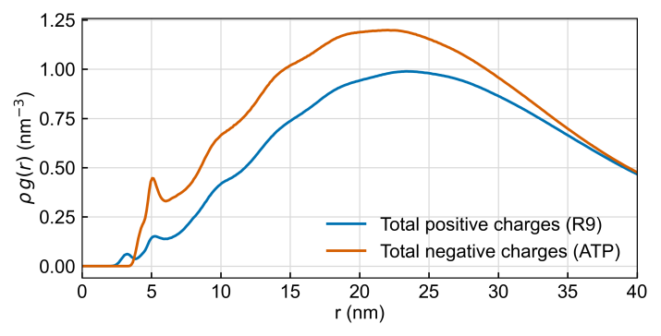 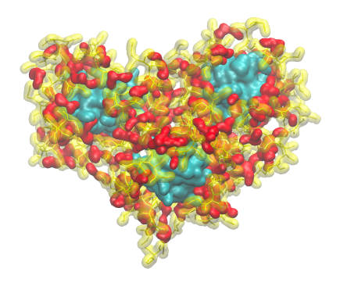

**Figure S1. Radial charge distribution and representative snapshot of the micelle crown. (a) Radial charge distribution functions ρg(r) between LVFF core atoms and the total positive charges (R9, cyan) as well as the total negative charges (ATP, yellow). The profiles show that positive charges preferentially localize at ~5–6 nm from the LVFF core, consistent with the formation of a positively charged crown, whereas negative charges exhibit a broader distribution. (b) Representative snapshot from the 20 μs trajectory illustrating the spatial organization of the aggregates (LVFF in cyan, R9 in yellow, ATP in red). The R9 segments form a crown-like arrangement surrounding the LVFF hydrophobic core, consistent with the interpretation in Section 2.4. See also Movie S1 for the temporal evolution of this organization.**

**Movie S1. Time evolution of peptide–ATP co-assembly over 20 μs. The movie illustrates the spatial organization of the system during the self-assembly process. LVFF segments are colored in cyan, R9 segments in yellow, and ATP molecules in red. The trajectory highlights the formation of micelle-like structures, with R9 residues organizing into a positively charged crown around the hydrophobic LVFF core.**